Технологии программирования
Лабораторная работа №4

"Пути и циклы в графе"

Подготовил студент
Группы А-14-18
Сергеев Максим
Вариант 16

- Задание
Разработать приложение на языке Java, реализующее указанное задание. Должны использоваться элементы библиотеки Swing.
Программа должна обеспечивать ввод описания графа с клавиатуры (с помощью мыши).
Программа должна обеспечивать представление исходного графа и результатов в графическом виде.
В программе должны использоваться меню и диалоговые окна.
16.Сергеев М.С. – Найти самый короткий цикл, проходящий через два заданных ребра и заданную вершину.
- Описание работы программы
- Вводим граф в виде множества списков смежных вершин. Вводим параметры поиска цикла(вершину и два ребра)
- Ищем кратчайшие циклы: Обход графа начинаем с вводимой нами вершины. Ищем путь который приводит в эту же вершину, если приходим в тупик возвращаемся обратно к предыдущим точкам. Проверяем этот путь на вхождение в него вводимых нами ребер, если все условия соблюдены, то записываем цикл в матрицу вывода. Возвращаемся обратно по предыдущему пути и продолжаем искать циклы, удовлетворяющие нашим параметрам, до тех пор, пока не исследуем весь граф
- Из всех найденных нами циклов, записанных в матрицу вывода, выбираем кратчайшие
- Рисуем графы
- Тесты и распечатка работы программы
Тест 1
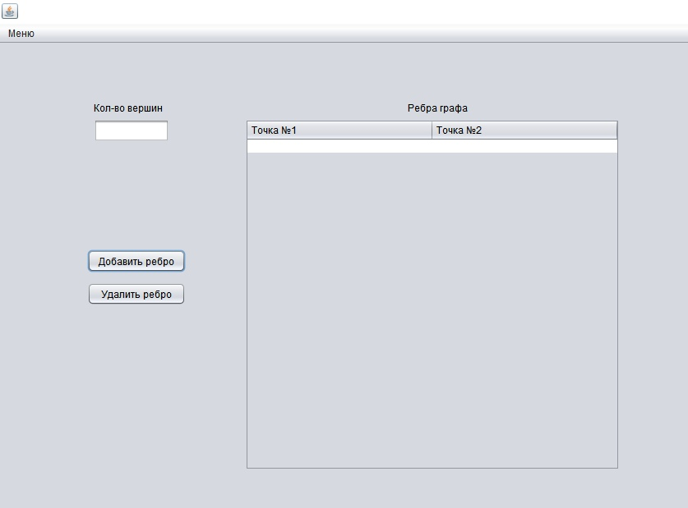
- Ввод графа
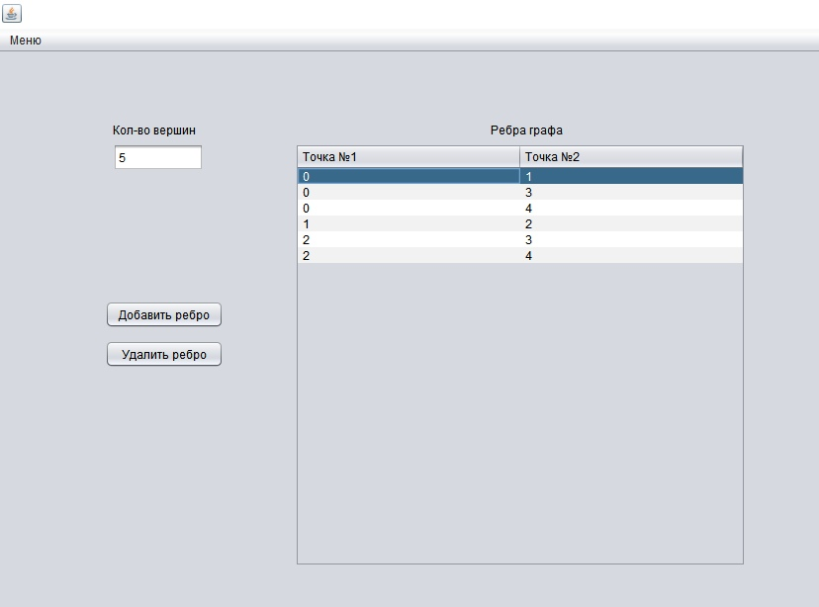
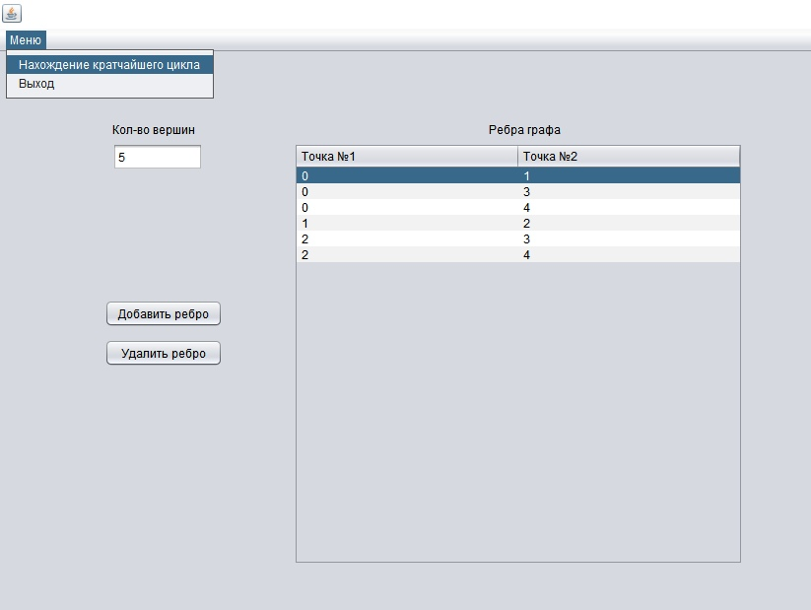
- Нахождение кратчайших циклов
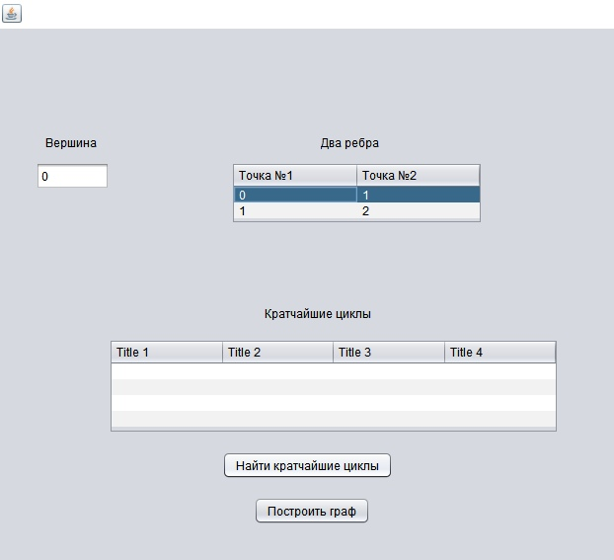
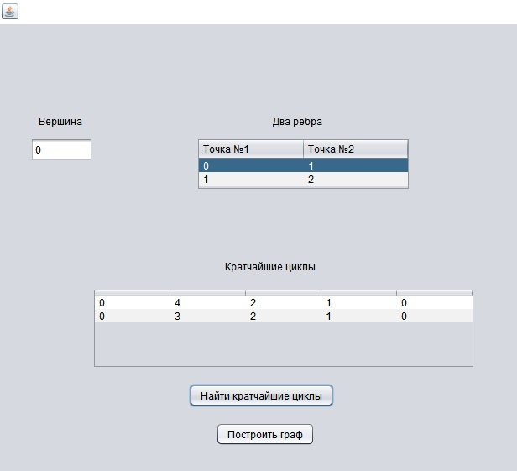
- Отображение результатов
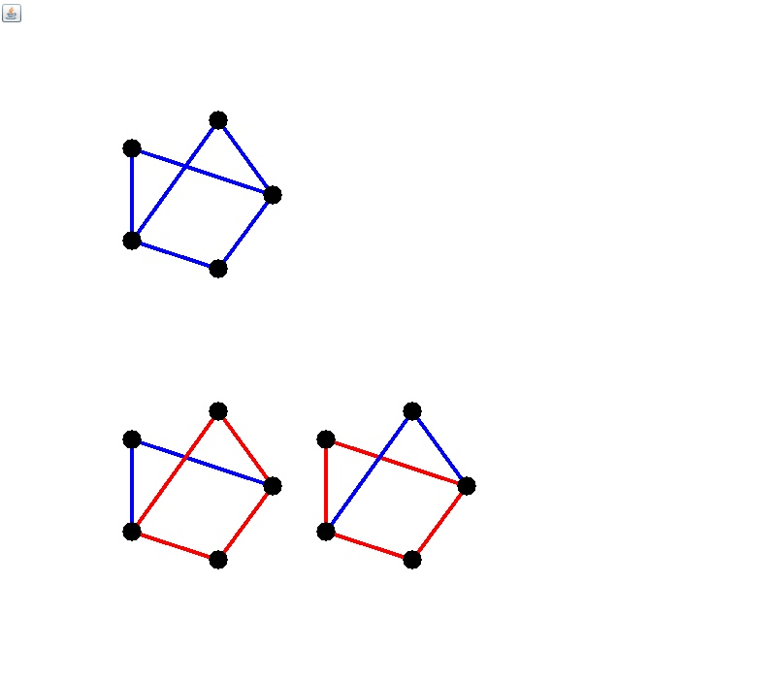
Тест 2
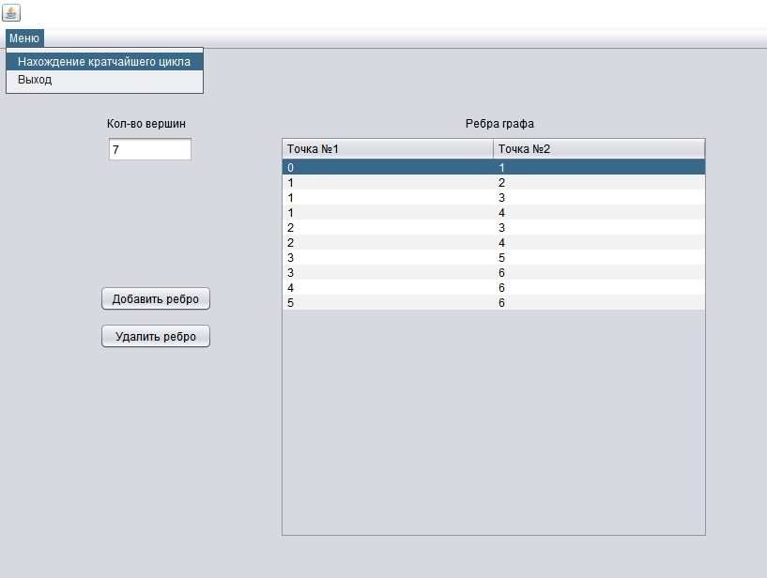
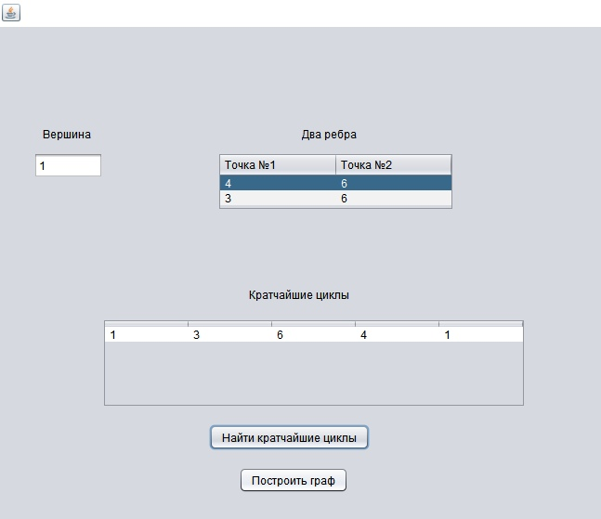
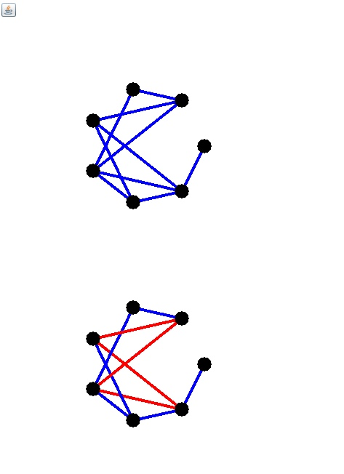
Тест 3
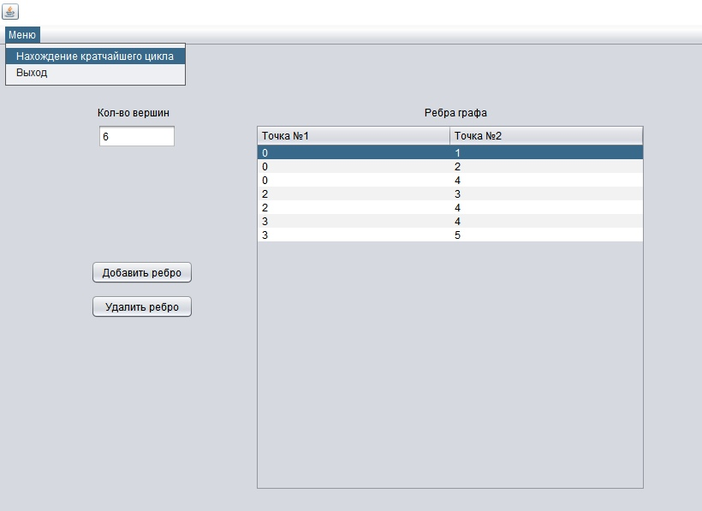
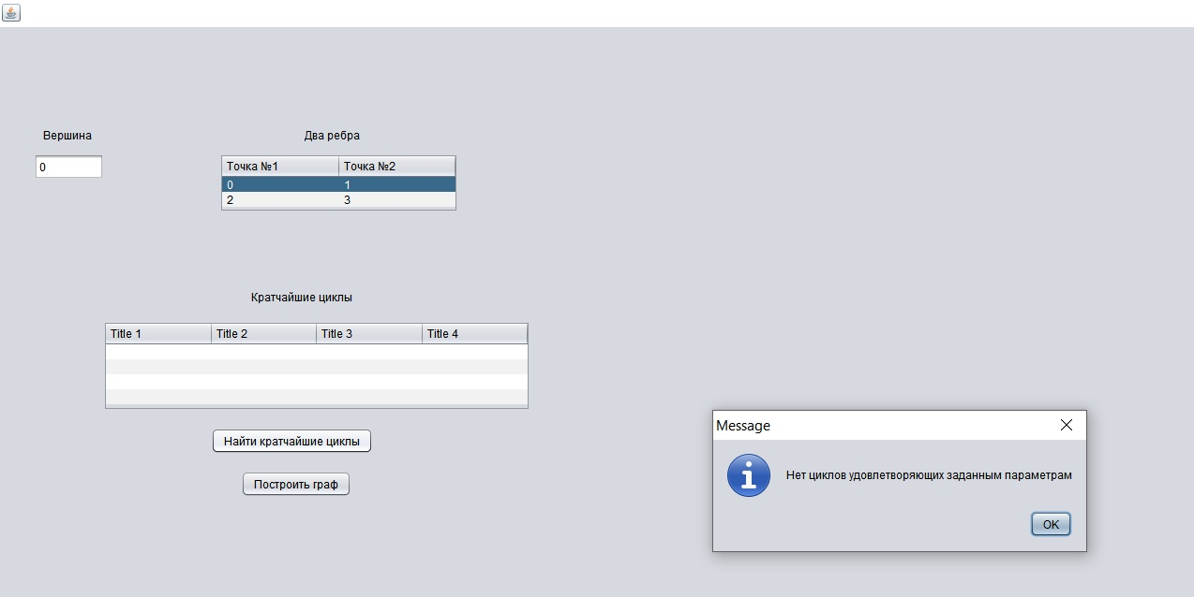
- Листинг
- Form1.java(главная форма)
import javax.swing.table.DefaultTableModel;
/*
* To change this license header, choose License Headers in Project Properties.
* To change this template file, choose Tools | Templates
* and open the template in the editor.
*/

/**
*
* @author Максим
*/
public class Form1 extends javax.swing.JFrame {

static String n;
static String [][] m;
static Integer k = 0;
/**
* Creates new form Form1
*/
public Form1() {
initComponents();
DefaultTableModel model = (DefaultTableModel)jTable1.getModel();
model.setRowCount(6);
model.setColumnCount(2);
//TableColumn col1 = new TableColumn();
//TableColumn col2 = new TableColumn();
//jTable1.addColumn(col1);
//jTable1.addColumn(col2);
//jTable1.getColumnModel().getColumn(0).setHeaderValue("Точка №1");
//jTable1.getColumnModel().getColumn(1).setHeaderValue("Точка №2");
}

/**
* This method is called from within the constructor to initialize the form.
* WARNING: Do NOT modify this code. The content of this method is always
* regenerated by the Form Editor.
*/
@SuppressWarnings("unchecked")
// <editor-fold defaultstate="collapsed" desc="Generated Code">
private void initComponents() {

jLabel1 = new javax.swing.JLabel();
jTextField1 = new javax.swing.JTextField();
jLabel2 = new javax.swing.JLabel();
jButton1 = new javax.swing.JButton();
jButton2 = new javax.swing.JButton();
jButton3 = new javax.swing.JButton();
jScrollPane1 = new javax.swing.JScrollPane();
jTable1 = new javax.swing.JTable();
jMenuBar1 = new javax.swing.JMenuBar();
jMenu1 = new javax.swing.JMenu();
jMenuItem1 = new javax.swing.JMenuItem();
jMenuItem2 = new javax.swing.JMenuItem();

setDefaultCloseOperation(javax.swing.WindowConstants.EXIT_ON_CLOSE);

jLabel1.setText("Кол-во вершин");

jTextField1.addActionListener(new java.awt.event.ActionListener() {
public void actionPerformed(java.awt.event.ActionEvent evt) {
jTextField1ActionPerformed(evt);
}
});

jLabel2.setText("Ребра графа");

jButton1.setText("Добавить ребро");
jButton1.addActionListener(new java.awt.event.ActionListener() {
public void actionPerformed(java.awt.event.ActionEvent evt) {
jButton1ActionPerformed(evt);
}
});

jButton2.setText("Удалить ребро");
jButton2.addActionListener(new java.awt.event.ActionListener() {
public void actionPerformed(java.awt.event.ActionEvent evt) {
jButton2ActionPerformed(evt);
}
});

jButton3.setText("Построить граф");
jButton3.addActionListener(new java.awt.event.ActionListener() {
public void actionPerformed(java.awt.event.ActionEvent evt) {
jButton3ActionPerformed(evt);
}
});

jTable1.setModel(new javax.swing.table.DefaultTableModel(
new Object [][] {
{"", ""},
},
new String [] {
"Точка №1", "Точка №2"
}
) {
Class[] types = new Class [] {
java.lang.String.class, java.lang.String.class
};

public Class getColumnClass(int columnIndex) {
return types [columnIndex];
}
});
jScrollPane1.setViewportView(jTable1);

jMenu1.setText("Меню");

jMenuItem1.setText("Нахождение кратчайшего цикла");
jMenuItem1.addActionListener(new java.awt.event.ActionListener() {
public void actionPerformed(java.awt.event.ActionEvent evt) {
jMenuItem1ActionPerformed(evt);
}
});
jMenu1.add(jMenuItem1);

jMenuItem2.setText("Выход");
jMenuItem2.addActionListener(new java.awt.event.ActionListener() {
public void actionPerformed(java.awt.event.ActionEvent evt) {
jMenuItem2ActionPerformed(evt);
}
});
jMenu1.add(jMenuItem2);

jMenuBar1.add(jMenu1);

setJMenuBar(jMenuBar1);

javax.swing.GroupLayout layout = new javax.swing.GroupLayout(getContentPane());
getContentPane().setLayout(layout);
layout.setHorizontalGroup(
layout.createParallelGroup(javax.swing.GroupLayout.Alignment.LEADING)
.addGroup(layout.createSequentialGroup()
.addGroup(layout.createParallelGroup(javax.swing.GroupLayout.Alignment.LEADING)
.addGroup(layout.createSequentialGroup()
.addGap(114, 114, 114)
.addGroup(layout.createParallelGroup(javax.swing.GroupLayout.Alignment.LEADING, false)
.addComponent(jTextField1)
.addComponent(jLabel1, javax.swing.GroupLayout.DEFAULT_SIZE, 92, Short.MAX_VALUE)))
.addGroup(layout.createSequentialGroup()
.addGap(106, 106, 106)
.addGroup(layout.createParallelGroup(javax.swing.GroupLayout.Alignment.LEADING, false)
.addComponent(jButton1, javax.swing.GroupLayout.DEFAULT_SIZE, javax.swing.GroupLayout.DEFAULT_SIZE, Short.MAX_VALUE)
.addComponent(jButton2, javax.swing.GroupLayout.DEFAULT_SIZE, javax.swing.GroupLayout.DEFAULT_SIZE, Short.MAX_VALUE))))
.addGroup(layout.createParallelGroup(javax.swing.GroupLayout.Alignment.LEADING)
.addGroup(layout.createSequentialGroup()
.addGap(270, 270, 270)
.addComponent(jLabel2))
.addGroup(layout.createSequentialGroup()
.addGap(72, 72, 72)
.addComponent(jScrollPane1, javax.swing.GroupLayout.PREFERRED_SIZE, javax.swing.GroupLayout.DEFAULT_SIZE, javax.swing.GroupLayout.PREFERRED_SIZE)))
.addContainerGap(152, Short.MAX_VALUE))
.addGroup(javax.swing.GroupLayout.Alignment.TRAILING, layout.createSequentialGroup()
.addGap(0, 0, Short.MAX_VALUE)
.addComponent(jButton3)
.addGap(300, 300, 300))
);
layout.setVerticalGroup(
layout.createParallelGroup(javax.swing.GroupLayout.Alignment.LEADING)
.addGroup(layout.createSequentialGroup()
.addGap(71, 71, 71)
.addGroup(layout.createParallelGroup(javax.swing.GroupLayout.Alignment.BASELINE)
.addComponent(jLabel1)
.addComponent(jLabel2))
.addPreferredGap(javax.swing.LayoutStyle.ComponentPlacement.RELATED)
.addGroup(layout.createParallelGroup(javax.swing.GroupLayout.Alignment.LEADING)
.addGroup(layout.createSequentialGroup()
.addComponent(jTextField1, javax.swing.GroupLayout.PREFERRED_SIZE, javax.swing.GroupLayout.DEFAULT_SIZE, javax.swing.GroupLayout.PREFERRED_SIZE)
.addGap(131, 131, 131)
.addComponent(jButton1)
.addPreferredGap(javax.swing.LayoutStyle.ComponentPlacement.UNRELATED)
.addComponent(jButton2))
.addComponent(jScrollPane1, javax.swing.GroupLayout.PREFERRED_SIZE, javax.swing.GroupLayout.DEFAULT_SIZE, javax.swing.GroupLayout.PREFERRED_SIZE))
.addPreferredGap(javax.swing.LayoutStyle.ComponentPlacement.RELATED, javax.swing.GroupLayout.DEFAULT_SIZE, Short.MAX_VALUE)
.addComponent(jButton3)
.addGap(28, 28, 28))
);

pack();
}// </editor-fold>

private void jMenuItem2ActionPerformed(java.awt.event.ActionEvent evt) {
// TODO add your handling code here:
System.exit(0);
}

private void jButton1ActionPerformed(java.awt.event.ActionEvent evt) {
DefaultTableModel model = (DefaultTableModel)jTable1.getModel();
model.addRow(new Object[]{});
}

private void jButton3ActionPerformed(java.awt.event.ActionEvent evt) {
// TODO add your handling code here:
Form2 frm = new Form2();
n = jTextField1.getText();
m = new String[jTable1.getRowCount()][2];
for(int i=0;i<jTable1.getRowCount();i++)
{
m[i][0] = jTable1.getValueAt(i, 0).toString();
m[i][1] = jTable1.getValueAt(i, 1).toString();
}
frm.setVisible(true);
}

private void jButton2ActionPerformed(java.awt.event.ActionEvent evt) {
// TODO add your handling code here:
DefaultTableModel model = (DefaultTableModel)jTable1.getModel();
model.removeRow(model.getRowCount()-1);
}

private void jTextField1ActionPerformed(java.awt.event.ActionEvent evt) {
// TODO add your handling code here:
}

private void jMenuItem1ActionPerformed(java.awt.event.ActionEvent evt) {
// TODO add your handling code here:
Form3 f3 = new Form3();
n = jTextField1.getText();
m = new String[jTable1.getRowCount()][2];
for(int i=0;i<jTable1.getRowCount();i++)
{
m[i][0] = jTable1.getValueAt(i, 0).toString();
m[i][1] = jTable1.getValueAt(i, 1).toString();
}
f3.setVisible(true);
}
public javax.swing.JTextField getTextField() {
return this.jTextField1;
}
public javax.swing.JTable getTable() {
return this.jTable1;
}
/**
* @param args the command line arguments
*/
public static void main(String args[]) {
/* Set the Nimbus look and feel */
//<editor-fold defaultstate="collapsed" desc=" Look and feel setting code (optional) ">
/* If Nimbus (introduced in Java SE 6) is not available, stay with the default look and feel.
* For details see http://download.oracle.com/javase/tutorial/uiswing/lookandfeel/plaf.html
*/
try {
for (javax.swing.UIManager.LookAndFeelInfo info : javax.swing.UIManager.getInstalledLookAndFeels()) {
if ("Nimbus".equals(info.getName())) {
javax.swing.UIManager.setLookAndFeel(info.getClassName());
break;
}
}
} catch (ClassNotFoundException ex) {
java.util.logging.Logger.getLogger(Form1.class.getName()).log(java.util.logging.Level.SEVERE, null, ex);
} catch (InstantiationException ex) {
java.util.logging.Logger.getLogger(Form1.class.getName()).log(java.util.logging.Level.SEVERE, null, ex);
} catch (IllegalAccessException ex) {
java.util.logging.Logger.getLogger(Form1.class.getName()).log(java.util.logging.Level.SEVERE, null, ex);
} catch (javax.swing.UnsupportedLookAndFeelException ex) {
java.util.logging.Logger.getLogger(Form1.class.getName()).log(java.util.logging.Level.SEVERE, null, ex);
}
//</editor-fold>

/* Create and display the form */
java.awt.EventQueue.invokeLater(new Runnable() {
public void run() {
new Form1().setVisible(true);
}
});
}

// Variables declaration - do not modify
private javax.swing.JButton jButton1;
private javax.swing.JButton jButton2;
private javax.swing.JButton jButton3;
private javax.swing.JLabel jLabel1;
private javax.swing.JLabel jLabel2;
private javax.swing.JMenu jMenu1;
private javax.swing.JMenuBar jMenuBar1;
private javax.swing.JMenuItem jMenuItem1;
private javax.swing.JMenuItem jMenuItem2;
private javax.swing.JScrollPane jScrollPane1;
private javax.swing.JTable jTable1;
public javax.swing.JTextField jTextField1;
// End of variables declaration
}

- Form2.java(построение графов)
import java.awt.*;
/*
* To change this license header, choose License Headers in Project Properties.
* To change this template file, choose Tools | Templates
* and open the template in the editor.
*/

/**
*
* @author Максим
*/
public class Form2 extends javax.swing.JFrame {

/**
* Creates new form Form2
*/
public Form2() {
initComponents();
}
public void paint(Graphics g)
{
Graphics2D g2 = (Graphics2D)g;
//g2.setPaint(Color.BLUE);
//g2.setStroke(new BasicStroke(4));
//g2.drawLine(50,50, 100, 100);
int nv =Integer.parseInt(Form1.n);
int x,y;
double k = (2*Math.PI)/nv;
int [][] matr = new int[nv][2];
for(int i = 0; i<nv; i++)
{
x = (int) (Math.cos(i*k)*80+200);
y = (int) (Math.sin(i*k)*80+200);
matr[i][0] = x;
matr[i][1] = y;
}
int i=0;
g2.setPaint(Color.blue);
g2.setStroke(new BasicStroke(4));
while (i<(Form1.m.length))
{
int a = Integer.parseInt(Form1.m[i][0]);
int b = Integer.parseInt(Form1.m[i][1]);
g2.drawLine(matr[a][0]+10, matr[a][1]+10, matr[b][0]+10, matr[b][1]+10);
i+=1;
}
g2.setPaint(Color.BLACK);
for (int j=0;j<nv;j++)
{
g2.fillOval(matr[j][0], matr[j][1], 20, 20);
}
if (Form1.k!=0)
{
int n = Form3.mk.length;
int r = 0;
boolean fl;
for (int j = 0; j < n; j++)
{
for (i = 0; i < nv; i++)
{
x = (int)(80 * Math.cos(i * k) + 200 + r);
y = (int)(80 * Math.sin(i * k) + 500);
matr[i][0] = x;
matr[i][1] = y;
}
i = 0;
while (i<Form1.m.length)
{
fl = true;
int a = Integer.parseInt(Form1.m[i][0]);
int b = Integer.parseInt(Form1.m[i][1]);
for(int s=0; s<(Form3.mk[j].length-1);s++)
{
if((Integer.parseInt(Form3.mk[j][s]) == a && Integer.parseInt(Form3.mk[j][s+1])==b) || (Integer.parseInt(Form3.mk[j][s+1]) == a && Integer.parseInt(Form3.mk[j][s]) == b))
{
fl = false;
}
}
if (fl==false)
{
g2.setPaint(Color.RED);
g2.drawLine(matr[a][0] + 10, matr[a][1] + 10, matr[b][0] + 10, matr[b][1] + 10);
}
else
{
g2.setPaint(Color.BLUE);
g2.drawLine(matr[a][0] + 10, matr[a][1] + 10, matr[b][0] + 10, matr[b][1] + 10);
}
i += 1;
}
g2.setPaint(Color.BLACK);
for (int t = 0; t < nv; t++)
{
g2.fillOval(matr[t][0], matr[t][1], 20, 20);
}
r += 200;
}
}

}
/**
* This method is called from within the constructor to initialize the form.
* WARNING: Do NOT modify this code. The content of this method is always
* regenerated by the Form Editor.
*/
@SuppressWarnings("unchecked")
// <editor-fold defaultstate="collapsed" desc="Generated Code">
private void initComponents() {

setDefaultCloseOperation(javax.swing.WindowConstants.EXIT_ON_CLOSE);

javax.swing.GroupLayout layout = new javax.swing.GroupLayout(getContentPane());
getContentPane().setLayout(layout);
layout.setHorizontalGroup(
layout.createParallelGroup(javax.swing.GroupLayout.Alignment.LEADING)
.addGap(0, 939, Short.MAX_VALUE)
);
layout.setVerticalGroup(
layout.createParallelGroup(javax.swing.GroupLayout.Alignment.LEADING)
.addGap(0, 791, Short.MAX_VALUE)
);

pack();
}// </editor-fold>

/**
* @param args the command line arguments
*/
public static void main(String args[]) {
/* Set the Nimbus look and feel */
//<editor-fold defaultstate="collapsed" desc=" Look and feel setting code (optional) ">
/* If Nimbus (introduced in Java SE 6) is not available, stay with the default look and feel.
* For details see http://download.oracle.com/javase/tutorial/uiswing/lookandfeel/plaf.html
*/
try {
for (javax.swing.UIManager.LookAndFeelInfo info : javax.swing.UIManager.getInstalledLookAndFeels()) {
if ("Nimbus".equals(info.getName())) {
javax.swing.UIManager.setLookAndFeel(info.getClassName());
break;
}
}
} catch (ClassNotFoundException ex) {
java.util.logging.Logger.getLogger(Form2.class.getName()).log(java.util.logging.Level.SEVERE, null, ex);
} catch (InstantiationException ex) {
java.util.logging.Logger.getLogger(Form2.class.getName()).log(java.util.logging.Level.SEVERE, null, ex);
} catch (IllegalAccessException ex) {
java.util.logging.Logger.getLogger(Form2.class.getName()).log(java.util.logging.Level.SEVERE, null, ex);
} catch (javax.swing.UnsupportedLookAndFeelException ex) {
java.util.logging.Logger.getLogger(Form2.class.getName()).log(java.util.logging.Level.SEVERE, null, ex);
}
//</editor-fold>

/* Create and display the form */
java.awt.EventQueue.invokeLater(new Runnable() {
public void run() {
new Form2().setVisible(true);
}
});
}

// Variables declaration - do not modify
// End of variables declaration
}

- Form3.java(форма для нахождения кратчайших циклов)
import javax.swing.JOptionPane;
import javax.swing.table.DefaultTableModel;
/**
*
* @author Максим
*/
public class Form3 extends javax.swing.JFrame {

static String [][] mk;
/**
* Creates new form Form3
*/
public Form3() {
initComponents();
DefaultTableModel model = (DefaultTableModel)jTable2.getModel();

}

/**
* This method is called from within the constructor to initialize the form.
* WARNING: Do NOT modify this code. The content of this method is always
* regenerated by the Form Editor.
*/
@SuppressWarnings("unchecked")
// <editor-fold defaultstate="collapsed" desc="Generated Code">
private void initComponents() {

jLabel1 = new javax.swing.JLabel();
jTextField1 = new javax.swing.JTextField();
jLabel2 = new javax.swing.JLabel();
jScrollPane1 = new javax.swing.JScrollPane();
jTable1 = new javax.swing.JTable();
jLabel3 = new javax.swing.JLabel();
jScrollPane2 = new javax.swing.JScrollPane();
jTable2 = new javax.swing.JTable();
jButton1 = new javax.swing.JButton();
jButton2 = new javax.swing.JButton();

setDefaultCloseOperation(javax.swing.WindowConstants.EXIT_ON_CLOSE);

jLabel1.setText("Вершина");

jLabel2.setText("Два ребра");

jTable1.setModel(new javax.swing.table.DefaultTableModel(
new Object [][] {
{null, null},
{null, null}
},
new String [] {
"Точка №1", "Точка №2"
}
));
jScrollPane1.setViewportView(jTable1);

jLabel3.setText("Кратчайшие циклы");

jTable2.setModel(new javax.swing.table.DefaultTableModel(
new Object [][] {
{null, null, null, null},
{null, null, null, null},
{null, null, null, null},
{null, null, null, null}
},
new String [] {
"Title 1", "Title 2", "Title 3", "Title 4"
}
));
jScrollPane2.setViewportView(jTable2);

jButton1.setText("Найти кратчайшие циклы");
jButton1.addActionListener(new java.awt.event.ActionListener() {
public void actionPerformed(java.awt.event.ActionEvent evt) {
jButton1ActionPerformed(evt);
}
});

jButton2.setText("Построить граф");
jButton2.addActionListener(new java.awt.event.ActionListener() {
public void actionPerformed(java.awt.event.ActionEvent evt) {
jButton2ActionPerformed(evt);
}
});

javax.swing.GroupLayout layout = new javax.swing.GroupLayout(getContentPane());
getContentPane().setLayout(layout);
layout.setHorizontalGroup(
layout.createParallelGroup(javax.swing.GroupLayout.Alignment.LEADING)
.addGroup(layout.createSequentialGroup()
.addGroup(layout.createParallelGroup(javax.swing.GroupLayout.Alignment.LEADING)
.addGroup(layout.createSequentialGroup()
.addGap(46, 46, 46)
.addComponent(jLabel1)
.addGap(227, 227, 227)
.addComponent(jLabel2))
.addGroup(layout.createSequentialGroup()
.addGap(36, 36, 36)
.addComponent(jTextField1, javax.swing.GroupLayout.PREFERRED_SIZE, 75, javax.swing.GroupLayout.PREFERRED_SIZE)
.addGap(123, 123, 123)
.addComponent(jScrollPane1, javax.swing.GroupLayout.PREFERRED_SIZE, 255, javax.swing.GroupLayout.PREFERRED_SIZE))
.addGroup(layout.createSequentialGroup()
.addGap(110, 110, 110)
.addComponent(jScrollPane2, javax.swing.GroupLayout.PREFERRED_SIZE, javax.swing.GroupLayout.DEFAULT_SIZE, javax.swing.GroupLayout.PREFERRED_SIZE))
.addGroup(layout.createSequentialGroup()
.addGap(225, 225, 225)
.addComponent(jButton1))
.addGroup(layout.createSequentialGroup()
.addGap(257, 257, 257)
.addComponent(jButton2))
.addGroup(layout.createSequentialGroup()
.addGap(268, 268, 268)
.addComponent(jLabel3)))
.addContainerGap(287, Short.MAX_VALUE))
);
layout.setVerticalGroup(
layout.createParallelGroup(javax.swing.GroupLayout.Alignment.LEADING)
.addGroup(layout.createSequentialGroup()
.addGap(107, 107, 107)
.addGroup(layout.createParallelGroup(javax.swing.GroupLayout.Alignment.BASELINE)
.addComponent(jLabel1)
.addComponent(jLabel2))
.addPreferredGap(javax.swing.LayoutStyle.ComponentPlacement.UNRELATED)
.addGroup(layout.createParallelGroup(javax.swing.GroupLayout.Alignment.LEADING)
.addComponent(jTextField1, javax.swing.GroupLayout.PREFERRED_SIZE, javax.swing.GroupLayout.DEFAULT_SIZE, javax.swing.GroupLayout.PREFERRED_SIZE)
.addComponent(jScrollPane1, javax.swing.GroupLayout.PREFERRED_SIZE, 63, javax.swing.GroupLayout.PREFERRED_SIZE))
.addGap(82, 82, 82)
.addComponent(jLabel3)
.addGap(18, 18, 18)
.addComponent(jScrollPane2, javax.swing.GroupLayout.PREFERRED_SIZE, 96, javax.swing.GroupLayout.PREFERRED_SIZE)
.addGap(18, 18, 18)
.addComponent(jButton1)
.addGap(18, 18, 18)
.addComponent(jButton2)
.addContainerGap(260, Short.MAX_VALUE))
);

pack();
}// </editor-fold>

private void jButton1ActionPerformed(java.awt.event.ActionEvent evt) {
// TODO add your handling code here:
Graph<Integer> result;
result = (Graph<Integer>) new Graph();
result.add_edge();
result.input_params();
result.kor_cycle();
if (jTable1.getRowCount() != 0)
Form1.k = 1;
}

private void jButton2ActionPerformed(java.awt.event.ActionEvent evt) {
// TODO add your handling code here:
Form2 f2 = new Form2();
mk = new String[jTable2.getRowCount()][jTable2.getColumnCount()];
for(int i=0;i<jTable2.getRowCount();i++)
{
for(int j=0;j<jTable2.getColumnCount();j++)
{
mk[i][j] = jTable2.getValueAt(i, j).toString();
}
}
f2.setVisible(true);
}

/**
* @param args the command line arguments
*/
public static void main(String args[]) {
/* Set the Nimbus look and feel */
//<editor-fold defaultstate="collapsed" desc=" Look and feel setting code (optional) ">
/* If Nimbus (introduced in Java SE 6) is not available, stay with the default look and feel.
* For details see http://download.oracle.com/javase/tutorial/uiswing/lookandfeel/plaf.html
*/
try {
for (javax.swing.UIManager.LookAndFeelInfo info : javax.swing.UIManager.getInstalledLookAndFeels()) {
if ("Nimbus".equals(info.getName())) {
javax.swing.UIManager.setLookAndFeel(info.getClassName());
break;
}
}
} catch (ClassNotFoundException ex) {
java.util.logging.Logger.getLogger(Form3.class.getName()).log(java.util.logging.Level.SEVERE, null, ex);
} catch (InstantiationException ex) {
java.util.logging.Logger.getLogger(Form3.class.getName()).log(java.util.logging.Level.SEVERE, null, ex);
} catch (IllegalAccessException ex) {
java.util.logging.Logger.getLogger(Form3.class.getName()).log(java.util.logging.Level.SEVERE, null, ex);
} catch (javax.swing.UnsupportedLookAndFeelException ex) {
java.util.logging.Logger.getLogger(Form3.class.getName()).log(java.util.logging.Level.SEVERE, null, ex);
}
//</editor-fold>

/* Create and display the form */
java.awt.EventQueue.invokeLater(new Runnable() {
public void run() {
new Form3().setVisible(true);
}
});
}
public javax.swing.JTextField getTextField() {
return this.jTextField1;
}
public javax.swing.JTable getTable1() {
return this.jTable1;
}
public javax.swing.JTable getTable2() {
return this.jTable2;
}
// Variables declaration - do not modify
private javax.swing.JButton jButton1;
private javax.swing.JButton jButton2;
private javax.swing.JLabel jLabel1;
private javax.swing.JLabel jLabel2;
private javax.swing.JLabel jLabel3;
private javax.swing.JScrollPane jScrollPane1;
private javax.swing.JScrollPane jScrollPane2;
private javax.swing.JTable jTable1;
private javax.swing.JTable jTable2;
private javax.swing.JTextField jTextField1;
// End of variables declaration
public class Node<T>
{
public Node(int data)
{
Data = data;
Next = null;
}
public int Data;
public Node<T> Next;
}
public class Graph<T>
{
private int V = 0;
Node<T>[] graph;
public int[][] Matrix;
private int vertex1 = 0;
private int[] first_edge = new int[] { 0, 0 };
private int[] second_edge = new int[] { 0, 0 };
private int len = 0;
/*public static M GetParametr<M>(object obj)where M: IConvertible
{
return (M)Convert.ChangeType(obj, typeof(M));
}*/
public void add_edge()
{
V = Integer.parseInt(Form1.n);
graph =(Node<T>[])new Node[V];
int i = 0;
while (i<(Form1.m.length))
{
int a = Integer.parseInt(Form1.m[i][0]);
int b = Integer.parseInt(Form1.m[i][1]);
edge(a,b);
i += 1;
}
}
public void print_graph()
{
DefaultTableModel model = (DefaultTableModel)jTable2.getModel();
model.setRowCount(0);
model.setColumnCount(0);
for (int i = 0; i < V+1; i++)
model.addColumn("");
for (int i = 0; i < V; i++)
model.addRow(new Object[]{});
for (int i = 0; i<V;i++)
{
jTable2.setValueAt(i, i, len);
Node<T> temp = graph[i];
int k = 1;
while (temp!=null)
{
jTable2.setValueAt(temp.Data, i, k);
temp = temp.Next;
k += 1;
}
}
}
public void edge(int src,int dest)
{
Node<T> node = new Node<T>(dest);
node.Next = graph[src];
graph[src] = node;

Node<T> node1 = new Node<T>(src);
node1.Next = graph[dest];
graph[dest] = node1;
}
public void input_params()
{
vertex1 = Integer.parseInt(jTextField1.getText());
first_edge[0] = Integer.parseInt(jTable1.getValueAt(0, 0).toString());
first_edge[1] = Integer.parseInt(jTable1.getValueAt(0, 1).toString());
second_edge[0] = Integer.parseInt(jTable1.getValueAt(1, 0).toString());
second_edge[1] = Integer.parseInt(jTable1.getValueAt(1, 1).toString());
}
public int [][] cycle()
{
boolean F = true;
boolean fl = true;
boolean fl1 = false;
boolean fl2 = false;
boolean fl3 = false;
boolean fl4 = true;
boolean fl5 = true;
int[][] M = new int[V * V][V + 1];
for (int gh = 0; gh < (V * V); gh++)
for (int gt = 0; gt < (V + 1); gt++)
M[gh][gt] = -1;
int i = vertex1;
int[] teccycle = new int[V + 1];
for (int gh = 0; gh < (V + 1); gh++)
teccycle[gh] = -1;
int[] mas1 = new int[V*V*V];
for (int gh = 0; gh < (V*V*V); gh++)
mas1[gh] = -1;
int[] masp = new int[10];
for (int gh = 0; gh < (10); gh++)
masp[gh] = -2;
int[][] matr = new int[100][V + 1];
for (int gh = 0; gh < (100); gh++)
for(int gt=0;gt<(V+1);gt++)
matr[gh][gt] = -1;
int[] new_mas = new int[V*V];
int[] mas = new int[V + 1];
mas1[0] = i;
teccycle[0] = i;
Node<T> temp = graph[i];
int t = 2;
int j = 1;
int k = 1;
int a = 0;
int b = 1;
int c = 0;
int l = 0;
int r = 0;
int m = 0;
int h = 0;
while (F)
{
while ((fl) && ((t - 2) >= 0))
{
//MessageBox.Show(Convert.ToString(j));
if (fl1 == true)
{
i = teccycle[j - 2];
teccycle[j - 1] = -1;
temp = graph[i];
j = j - 1;
}
fl1 = true;
fl3 = true;
fl5 = true;
m = 0;
while (temp!=null && fl1==true)
{
for (int y = 0; y < V; y++)
{
if (temp.Data == teccycle[y + 1])
fl1 = false;
}
for (int y = 0; y < l; y++)
{
if (temp.Data == masp[y])
{
fl5 = false;
fl1 = false;
}
}
if ((fl4 == true && fl1 == true) || teccycle[j - 1] == vertex1)
{
for (int y = 0; y < (V*V*V - 1); y++)
{
if ((teccycle[j - 1] == mas1[y] && temp.Data == mas1[y + 1]) || (teccycle[j - 1] == mas1[y + 1] && temp.Data == mas1[y]))
fl3 = false;
}
}
if (fl1 == true && fl5 == true && fl3 == true && temp.Data!=vertex1 && j!=1)
{
if (fl4 == true && a > 0)
{
h = 0;
for (int y = 0; y < a; y++)
{
fl4 = true;
for (int s = 0; s < (j + 1); s++)
{
if (s != j)
{
if (teccycle[s] != M[y][s])
fl4 = false;
}
else
{
if (temp.Data != M[y][s])
fl4 = false;
}
}
if (fl4 == true)
h += 1;
}
//MessageBox.Show(Convert.ToString(j));
if (h == 0)
{
fl3 = true;
fl4 = false;
for (int gh = 0; gh < (V*V); gh++)
new_mas[gh] = -1;
new_mas[0] = teccycle[j - 2];
new_mas[1] = teccycle[j - 1];
r = 2;
}
}
}
if (fl4 == false && fl1 == true)
{
for (int y = 0; y < (V*V - 1); y++)
{
if ((teccycle[j - 1] == new_mas[y] && temp.Data == new_mas[y + 1]) || (teccycle[j - 1] == new_mas[y + 1] && temp.Data == new_mas[y]))
fl3 = false;
}
}
if (fl1 == true && fl3 == true)
{
if (temp.Data == vertex1)
{
if (fl4 == true)
{
mas1[k] = temp.Data;
k += 1;
}
else
{
new_mas[r] = temp.Data;
r += 1;
}
teccycle[j] = temp.Data;
j += 1;
fl1 = false;
fl = false;
}
else
{
if (fl4 == true)
{
mas1[k] = temp.Data;
k += 1;
}
else
{
new_mas[r] = temp.Data;
r += 1;
}
teccycle[j] = temp.Data;
i = temp.Data;
temp = graph[i];
j += 1;
fl1 = false;
}
}
else
{
if (fl4 == true)
{
mas1[k] = teccycle[j - 1];
k += 1;
}
else
{
new_mas[r] = teccycle[j - 1];
r += 1;
}
temp = temp.Next;
if ((temp==null) && m == 0)
{
masp[l] = teccycle[j - 1];
l += 1;
}
m += 1;
fl1 = true;
}
fl3 = true;
}
t = j;
}
for (int y = 0; y < (V + 1); y++)
{
if ((teccycle[y] == first_edge[0] && teccycle[y + 1] == first_edge[1]) || (teccycle[y] == first_edge[1] && teccycle[y + 1] == first_edge[0]))
{
for (int s = 0; s < (V + 1); s++)
{
if ((teccycle[s] == second_edge[0] && teccycle[s + 1] == second_edge[1]) || (teccycle[s] == second_edge[1] && teccycle[s + 1] == second_edge[0]))
{
fl2 = true;
}
}
}
}
for (int gh = 0; gh < (V + 1); gh++)
mas[gh] = -1;
for (int y = 0; y < j; y++)
mas[y] = teccycle[y];
for (int y = 0; y < (V + 1); y++)
M[a][y] = mas[y];
if (fl2 == true)
{
//matr = insert(matr, [c], mas, axis = 0);
for (int y = 0; y < (V + 1); y++)
matr[c][y] = mas[y];
c += 1;
}
fl1 = true;
if (a > 0 && fl != true)
{
for (int y = 0; y < r; y++)
mas1[k + y] = new_mas[y];
k += r;
}
if (fl == true)
{
if (b == kol_rebr())
F = false;
else
{
temp = graph[vertex1];
for (int y = 0; y < b; y++)
temp = temp.Next;
b += 1;
for (int gh = 0; gh < (V*V*V); gh++)
mas1[gh] = -1;
mas1[0] = vertex1;
k = 1;
t = 2;
fl1 = false;
}
a -= 1;
}
fl4 = true;
fl2 = false;
fl = true;
a += 1;
}
return matr;
}
public int kol_rebr()
{
Node<T> temp = graph[vertex1];
int i = 0;
while (temp != null)
{
temp = temp.Next;
i += 1;
}
return i;
}
public void kor_cycle()
{
int [][] matr = cycle();
int min = V + 1;
int [][]Matrix1 = new int[10][V+1];
for (int i = 0; i < 10; i++)
for(int t=0;t<(V+1);t++)
Matrix1[i][t] = -1;
boolean F = false;
boolean fl3 = true;
int y = 0;
for (int i = 0; i < (99); i++)
{
int j = 0;
boolean fl = true;
while (j < (V+1) && fl==true)
{
if (matr[i][j] == -1 && (j - 1) == min && matr[i][0] != -1)
{
fl = false;
int[] mas1 = new int[j];
for (int t = 0; t < j; t++)
mas1[t] = matr[i][t];
int[] mas2 = new int[j];
for(int t=0; t<j;t++)
{
mas2[t] = mas1[j - t - 1];
}
fl3 = true;
int p = 0;
while (p < (y + 1) && fl3==true)
{
boolean fl1 = true;
boolean fl2 = true;
int[] mas3 = new int[j];
for (int s = 0; s < j; s++)
mas3[s] = Matrix1[p][s];
for (int k = 0; k < (V + 1); k++)
if (matr[i][k] != Matrix1[p][k])
fl1 = false;
for (int k = 0; k < j; k++)
{
if (mas2[k] != mas3[k])
fl2 = false;
}
if (fl1 == true || fl2 == true)
fl3 = false;
else
p += 1;
}
if (fl3 == true)
{
F = true;
for (int s = 0; s<(V+1);s++)
{
Matrix1[y][s] = matr[i][s];
}
y += 1;
//Matrix = np.insert(self.matr, y, matr[i], axis = 0);
}
}
if (matr[i][j] == -1 && (j - 1) < min && matr[i][0] != -1)
{
F = true;
int n = y;
y = 0;
for (int t = 0; t < n; t++)
for (int s = 0; s < (V + 1); s++)
Matrix1[t][s] = -1;
//Matrix = delete(self.matr, matr[t], axis = 0)
for (int t = 0; t < (V + 1); t++)
Matrix1[y][t] = matr[i][t];
//Matrix = np.insert(self.matr, y, matr[i], axis = 0);
y += 1;
fl = false;
min = j - 1;
}
j += 1;
}
}
Matrix = new int[y][min + 1];
for (int i = 0; i < y; i++)
for (int t = 0; t < (min + 1); t++)
Matrix[i][t] = Matrix1[i][t];
if (F == false)
JOptionPane.showMessageDialog(null, "Нет циклов удовлетворяющих заданным параметрам");
else
{
DefaultTableModel model = (DefaultTableModel)jTable2.getModel();
model.setRowCount(0);
model.setColumnCount(0);
for (int i = 0; i < (min + 1); i++)
model.addColumn("");
for (int i = 0; i < y; i++)
model.addRow(new Object[]{});
for (int i = 0; i < y; i++)
{
len += 1;
for(int t=0;t<(min+1);t++)
{
jTable2.setValueAt(Matrix[i][t], i, t);
}
}
}
}
}
}

